Four dances for four Gods

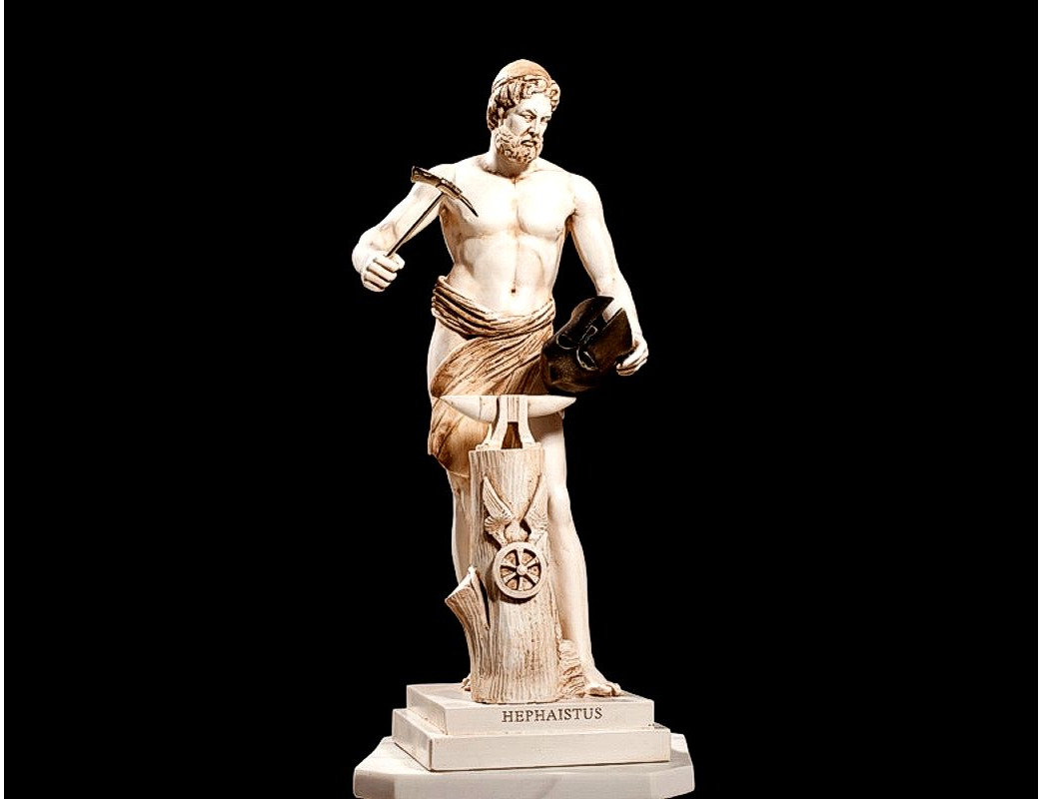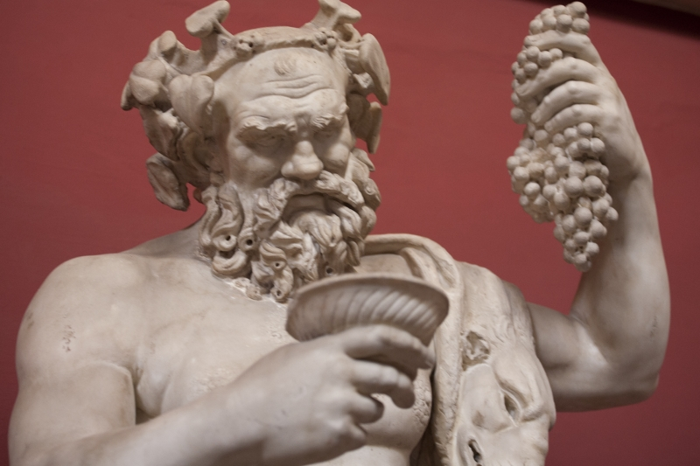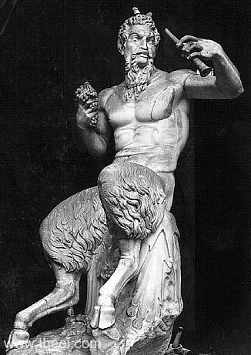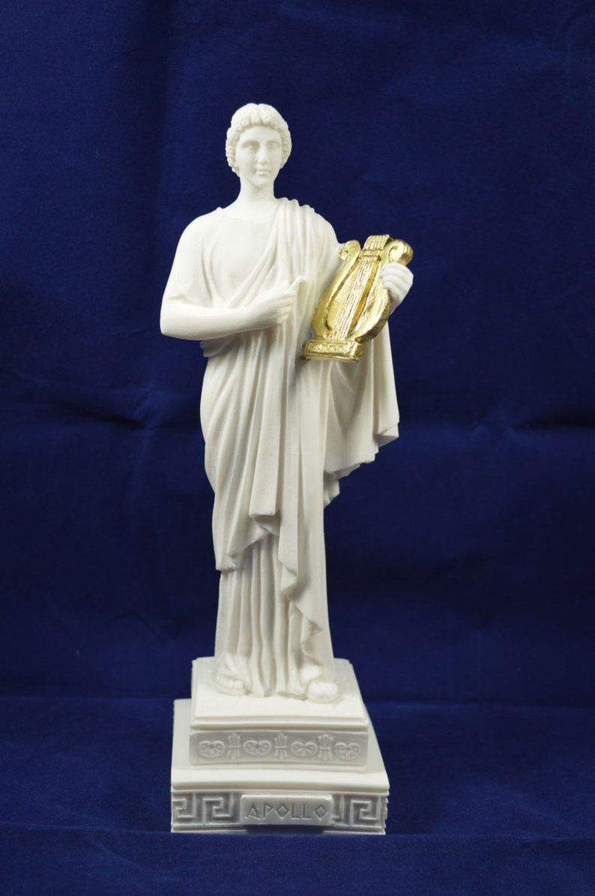

Dance is, first and most important, the oldest performing art, but as such, unfortunately, it is also the most disputed throughout history. That is why CID, as the supreme dance organization, and accordingly with that me personally, pay special attention to the earliest history of dance. Even in today’s age of the internet and other advanced technologies, it is very difficult to find relevant information about the origins and early development of dance as a cultural category. Therefore, in my research I use, in most cases, the methods and principles of the humanities, primarily linguistically oriented, because only through myths, legends and stories can find the true truth about the origin of dance, because, I repeat, dance is from the earliest days for various reasons fell into disfavor with all European religions, and, throughout history, most chroniclers can be found among church officials. But despite this, the dance has taken place, as such, throughout human history. Even, through its four dominant processes of liberation from these interdictions, it managed to develop and today represents a very developed branch of culture, art and entertainment. And so, following these myths, but also technically analyzing all known European dances, we can come to the conclusion that all, according to the dance scheme can be classified into four basic forms, or four basic types of dance. I emphasize that we are talking here about dances that, as we will prove, originated very early, but, although banned, have survived to this day, and have developed to such an extent that today we have world-famous Latino dances, which, although only a century old or a few years older, they also come from these four basic European dances.
Let's start by proving those claims. Although, perhaps, the first mention of dance was in Indian mythology, where it is said that Shiva created the world by dancing, the official scientific version says that the oldest mention of dance in writing is when the ancient Greek historian Herodotus mentioned "Partridge Dance" as a way to worshipers of the god Hephaestus should come to his temple in Athens. Hephaestus, according to mythology, was the god, the craftsman, who made all the relevant divine tools and weapons. Let's just list the basics: Zeus' lightning, Poseidon's trident, Hermes flying shoes and many others. For all his deeds, Zeus gave him his beloved daughter Aphrodite as his wife, therefore, the Temple of Hephaestus is in fact the Temple of Aphrodite, here in Athens. All the other gods, for the services done to them by Hephaestus, the other gods decided to repay him by giving him the "Partridge Dance" so named because of the partridge's ability to deceive enemies by imitating limping. According to myths and legends, Hephaestus was also lame, mostly because he worked with dangerous and poisonous substances, using health-hazardous elements in his smithy, making these weapons and tools for the gods.
For many years, it was thought that "Partridge Dance" itself was just a myth or that it got lost in dark times of history. However, at the archeological site near Vukovar, the Republic of Croatia, it is began to be established a museum of only one culture, which is named Vuchedol Culture after that site. Combining this research, knowledge and new methods of interpreting events from 5,000 years ago, when the Vuchedol Culture flourished, I presented my evidence and ideas at the 44th World Congress of Dance Research and showed that "Partridge Dance" is still alive today and it is danced in many forms with its six-beat scheme, and is best known in the world as the Minuet, and all its combinations, variations, and derivations. Because of a short time for this presentation, I would not dwell on the fate of "Partridge Dance" but only that its transformation from a typically aristocratic dance that is now presented as the national traditional dance of most southern European countries, from Austria to Turkey, is proof of the great moral and social power of dance which, despite prohibitions, has survived and undergone several transformations over 5,000 years of existence. He is also proof of the theory that in many cases the Middle Danube Valley, where Vuchedol is located, is the cradle of European civilization, which later moved to the Mediterranean, to the area of ​​today's Greece and, in part, Turkey.
And the time of the "Partridge Dance" itself can be easily proven through the myth of Hephaestus if some data from the natural sciences are connected. So, the myth of Hephaestus tells how he found his wife Aphrodite with the god of war Ares in his bed, and then he woven a bronze net so thin that it was invisible, and covered them with it. If we know what the variants of the names of the Greek and Roman gods are, and if we analyze astronomy a little, we come to a very strange and interesting coincidence. Namely, every 4987 years in the night sky happened a phenomenon that Mars (Greek Ares) and Venus (Greek Aphrodite) merge into one very bright celestial body and enter the constellation of the Pleiades. Conclusion is, assuming that the Pleiades are the house of Hephaestus, we can easily conclude that the myth of Hephaestus occurs and is constantly repeated approximately every 5,000 years. If we know the fact about the pit at the archeological site Vuchedol, with 8 skeletons, 6 of which are in a group on one side and 2 embraced on the other, it is clear that this is evidence of where and when the myth of Hephaestus originated, as well as where and when a dance dedicated to him arose. This also explains the scheme of the 6-part dance, which is the scheme of the Minuet and all its variations, combinations and derivations, due to the Pleiades as the house of Hephaestus.
Further, the myth of Hephaestus says that because of his action where he summoned the gods to see a couple in love covered with an invisible net, Hephaestus drew the wrath of Zeus, and thus Hephaestus lost his immortality, many other things, including his dance. Then the myth mentions that the dance is divided into two parts, one part to Dionysus, the god of wine, and the other to Pan, the god of forests, swamps and wilderness. If we analyze sociologically this division of "Dance of the Partridge" and at the same time knowing some newly discovered data about the Vučedol culture, we come to very interesting facts. First, at the time of the origin of both the myth of Hephaestus and the "Dance of the Partridge", Vuchedol was, we can say, the center of the world at that time. It is assumed that it had the economic, political, social and cultural value of today's Paris. This implies that it was urban in a high degree of meaning of that word. That is why this division emphasizes the severity of the punishment, because the dance was taken away from the serious and diligent craftsman Hephaestus and distributed to the lewd alcoholic Dionysus and the even more lewd and rural savage Pan. Secondly, the myth strangely tells us that later, for some unknown reason, the archeological site of Vučedol was abandoned, the system of some kind of proto-democracy was replaced by tribal division, and the advanced and urban part of the community moved to the Black Sea coast, founded the settlement of Troy.
These historical facts are indirectly related to dance, in moral and sociological terms, especially explain the 4 phases of dance release, because the first phase of dance release is directly related to Waltz. As proof of this fact, we can point out the fact that even today there is an ethnic group Walsers, spread over 4 Alpine countries, France, Germany, Italy and Austria, and where the highest peaks of the Alps. Knowing best of all these peaks of the Alps and the passes, even during the winter, they most likely used this knowledge to transport wine to the castles of noble families in these 4 states. Bringing wine, as a very valuable merchandise, they certainly had access to the ballrooms where professional dancers entertained the nobility. Later, they probably described to others what they saw, which was forbidden to the lower strata of society, so these refined and refined movements were called the Waltz. Even today, the most famous are the Waltz of Vienna and Paris, but Germany is also proud of its Waltz, while, unlike them, the same dance in Spain and Portugal is called differently. There is much more to be said about Waltz, but, to fit the time limit, this is the minimum we would say about Waltz, but still enough to prove its age and origin, because, all these historical facts show that Waltz the finer, noble part of the "Partridge Dance" assigned to Dionysus. Also, this "smuggling" of Waltz from the secrets of ballrooms can be called the first phase of the release of dance.
The story of Polka is different, but its content also proves the story of its origin through the myth of Hephaestus. So, with the departure of the most urban and democratic strata of the population to the shores of the Black Sea, only tribal communities remained in the Middle Danube region, and the penetration of other tribes from the west began, the value of bronze fell, and those tribes brought new metal, iron, so we can say that it was the beginning of a new, Iron Age. It is all related to the arrival of the Celts in these areas, and after them other Romans and Germanic tribes that led to the development of the Roman state, later the empire, while the natives retreated to forests, mountains and swamps, meaning a much wilder environment. symbolizes the god Pan, so the Romans named one of their provinces - Pannonia. These newly arrived tribes enslave the natives, so that even today these and such tribes have the name Slavs, which obviously has connection with slaves. Some of these tribes migrated to the northeast, to the area of ​​today's states of Belarus, Poland and Germany and maybe a few other states, but although they kept their Slavic name, new tribes are being created called by new names. Of these tribes, some emigrated back to the Balkans in the 6th and 7th centuries, and with it the Pan part of the dance, but later this dance was named after the then formed tribes in these Eastern European areas, meaning the Polish. Again, during the Roman Empire, especially later, remember the Middle Ages, dance was available only to the upper classes, and they also hid it from church officials, and yet the Russian and Polish nobility managed to preserve and develop the Polka through the millennia. as such, wild and wild, and simple, with a basic pattern of two triple steps, and this is, as in the case of Waltz, clear evidence that Hephaestus '"Partridge Dance" was divided into Dionysus' Waltz and Pan's Polka.
And finally, we are left with Apollo and the story of his dance, which is not directly related to the division of "Dance of the Partridge" but, in some versions, has to do with the myth of Hephaestus. Namely, according to some sources and some variants of the myth of Hephaestus, it was Apollo who told Hephaestus the news that his wife was in bed with Ares, and without going into a deeper analysis of his role in the ancient Greek divine world, we will only relate to that detail in the story. By the way, Apollo is the only god whose name remains in ancient Roman mythology, and most of the activities he performs. Here we will list only those artistic activities that are related to dance. The most important is that he was both the ancient Greek and the ancient Roman protector of music, and the proof of that is the lyre, which he holds in his hand in almost every performance. Because music is related to dance, in many myths Apollo is also the protector of dance. If we connect these two facts and analyze them through dance logic, the conclusion is that a dance that can be associated with Apollo is certainly one that matches in dance and music pattern. Of course, we are talking here about probably the most popular dance in the world, which, despite its popularity, has not been sufficiently researched, and which almost certainly originated at the same or close time as the previously mentioned 3 dances. So, we talk about the Quadrille. It is almost impossible to list all the variations, combinations and derivations of this dance that is present in any type of dance, from ballet to traditional dances, which certainly proves the fact about its age, but also about the power of creation that Quadrill evokes. By the way, it is known that dance is the art that evokes the most emotions, and here it is important to note that Quadrill is the basis for 99% of Latino dances where that emotion is the most important part of dance.
That is why it is reasonable to assume that these 4 dances were the basis of dance culture of ancient peoples and all kinds of current dances, which has lasted until today, and not only survived but continues to develop with all its strength using for its development as a creation individuals who are engaged in dance and the benefits of modern technology, thanks to which I have made this short analysis. So, for the end, let's repeat, in order since its inception, which was probably about 5,000 years ago, the dance culture of European peoples and those who rely on it are 4 dances for four gods, namely:
- Partridge dance or Minuet of the god Hephaestus
- Waltz of the god Dionysus
- Polka of the god Pan
- Quadrill of the god Apollo.

